**ITMO/IT-O 456 Laboratory Week 4 - chapter 6**

1. After your Linux system has been loaded, launch a terminal window

At the command prompt, type ls -F and press Enter.

At the command prompt, type mkdir mysamples and press Enter. Next, type ls -F at the command prompt and press Enter. How many files and subdirectories are there?

Three

At the command prompt, type cd mysamples and press Enter. Next, type ls -F at the command prompt and press Enter. What are the contents of the subdirectory mysamples?

Nothing.

At the command prompt, type mkdir undermysamples and press Enter. Next, type ls -F at the command prompt and press Enter. What are the contents of the subdirectory mysamples?

undermysamples/

At the command prompt, type mkdir todelete and press Enter. Next, type ls -F at the command prompt and press Enter. Does the subdirectory todelete you just created appear listed in the display?

Yes.

Provide screen shot of the results

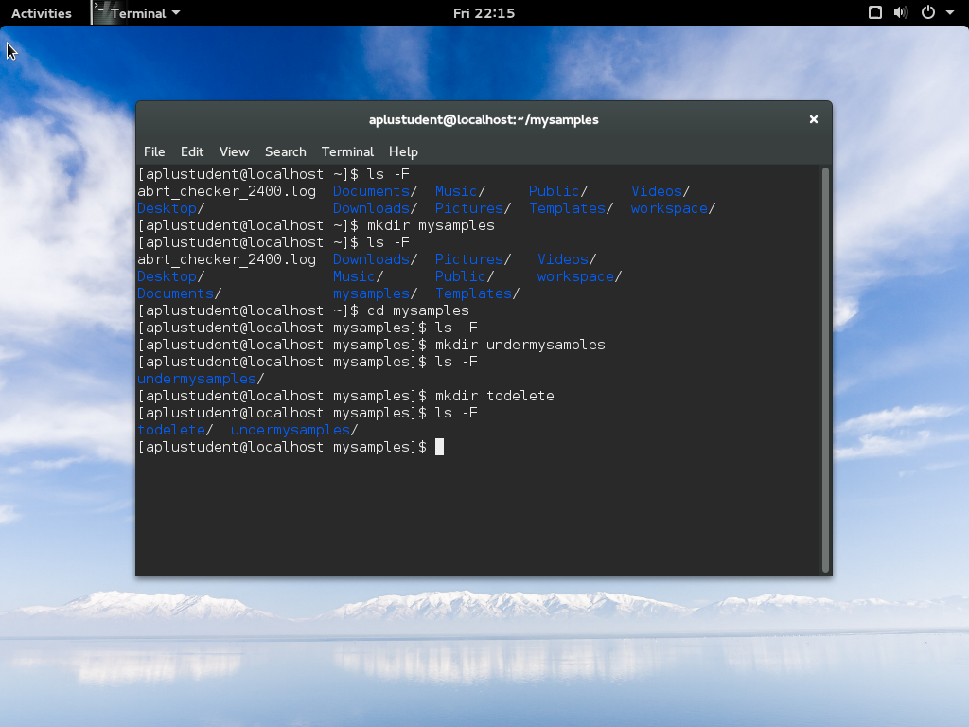

2. At the command prompt, type cd .. and press Enter. Next, type ls -R and press Enter. Notice that the subdirectory mysamples and its subdirectory undermysamples are both displayed. You have used the recursive option with the ls command.

At the command prompt, type cd .. and press Enter. At the command prompt, type pwd and press Enter. What is your current directory?

My current directory: /

At the command prompt, type sudo mkdir topsecret and press Enter. At the command prompt, type ls -F and press Enter. Does the subdirectory you just created appear listed in the display?

Yes.

Next, type ls -F at the command prompt and press Enter. Note the contents of your home folder.

boot/ home/ lost+found/ opt/ run/ sys/ topsecret/

3. At the command prompt, type touch sample1 and press Enter to create the file sample1.

At the command prompt, type cp sample1 and press Enter. What error message was displayed and why?

Error message: cp: missing destination file operand after ‘sample1’

Try ‘cp --help’ for more information.

Reason: cp is the command which makes a copy of your files or directories. Hence, you should have offer original file which you want to copy and the destination file which you will copy to.

At the command prompt, type cp sample1 sample1A and press Enter. Next, type ls -F at the command prompt and press Enter. How many files are there, and what are their names? Why?

They are two files, sample1 and sample1A because sample1 is copied.

At the command prompt, type cp sample1 mysamples/sample1B and press Enter. Next, type ls -F at the command prompt and press Enter. How many files are there, and what are their names? Why?

They are two files, sample1 and sample1A because the current directory does not show the file, sample1B and we need to change the directory to mysamples if we want to see this file.

At the command prompt, type cd mysamples and press Enter. Next, type ls -F at the command prompt and press Enter. Was sample1B copied successfully?

Yes.

4. At the command prompt, type cp /home/aplusstudent/sample2 . and press Enter. Next, type ls -F at the command prompt and press Enter. How many files are there, and what are their names? Why?

I create a file named sample2 in home directory. Then, I change the directory to Music/. After I run the command cp /home/aplusstudent/sample2 . and ls -F, I find the file of sample2 because I move this file from home directory to Music/.

At the command prompt, type cp sample1B .. and press Enter. Next, type cd .. at the command prompt and press Enter. At the command prompt, type ls -F and press Enter. Was the sample1B file copied successfully?

I run the command of cpsample1B .. in mysmaples/. After I run the command of ls -F, the sample1B file was copied successfully and it is in the home directory.

At the command prompt, type cp sample1 sample2 sample3 mysamples and press Enter. What message do you get and why? Choose y and press Enter. Next, type cd mysamples at the command prompt and press Enter. At the command prompt, type ls -F and press Enter. How many files are there, and what are their names? Why?

When I enter the directory, mysamples and use ls –F, there are three files, sample1 sample2 and sample3. The reason is I copy these three files to mysamples which is the destination.

At the command prompt, type cd .. and press Enter. Next, type cp mysamples mysamples2 at the command prompt and press Enter. What error message did you receive? Why?

Error message: cp: cannot stat ‘mysamples’: No such file or directory

The reason is the command, cd .. will take you up to 1 level. When you change the directory, you will not find the files in new directory.

At the command prompt, type cp -R mysamples mysamples2 and press Enter. Next, type ls -F at the command prompt and press Enter. Was the directory copied successfully? Type ls -F mysamples2 at the command prompt and press Enter. Were the contents of mysamples successfully copied to mysamples2?

Yes, the directory was copied successfully and the contents of mysamples were successfully copied to mysamples2.

Type ls -F at the command prompt and press Enter. Note the contents of your home folder.

At the command prompt, type mv sample1 and press Enter. What error message was displayed and why?

Error message: mv: missing destination file operand after ‘sample1’

Try ‘mv --help’ for more information.

Reason: this command only offer the source of the copy operation and miss the destination.

At the command prompt, type mv sample1 sample4 and press Enter. Next, type ls -F at the command prompt and press Enter. How many files are listed, and what are their names? What happened to sample1?

I only see sample4 because sample1 moved to sample4.

5. At the command prompt, type mv sample4 mysamples and press Enter. Next, type ls -F at the command prompt and press Enter. How many files are there, and what are their names? Where did sample4 go?

I only see mysamples and sample4 is gone because I moved sample4 to the directory, mysamples. Then, sample4 is under mysamples.

At the command prompt, type cd mysamples and press Enter. Next, type ls -F at the command prompt and press Enter. Notice that the sample4 file you moved in Step 5 was moved here.

At the command prompt, type mv sample4 .. and press Enter. Next, type ls -F at the command prompt and press Enter. How many files are there, and what are their names? Where did the sample4 file go?

I find sample4 is gone and it goes to the first level.

At the command prompt, type cd .. and press Enter. Next, type ls -F at the command prompt, and press Enter to view the new location of sample4.

At the command prompt, type mv sample4 mysamples/sample2 and press Enter. What message appeared on the screen and why?

Nothing. It means it works well.

Type y and press Enter to confirm you want to overwrite the file in the destination folder.

6. At the command prompt, type mv sample? mysamples and press Enter. Type y and press Enter to confirm you want to overwrite the file sample3 in the destination folder.

At the command prompt, type ls -F and press Enter. How many files are there and why?

The file, sample2, sample3 are gone because the command, mv sample? Mysamples just move these files to mysamples.

At the command prompt, type mv sample1* mysamples and press Enter. Type y and press Enter to confirm you want to overwrite the file sample1B in the destination directory.

At the command prompt, type ls -F and press Enter. Notice that there are no sample files in the /root directory.

At the command prompt, type cd mysamples and press Enter. Next, type ls -F at the command prompt and press Enter. Notice that all files originally in /root have been moved to this directory.

At the command prompt, type cd .. and press Enter. Next, type ls -F at the command prompt and press Enter. Type mv mysamples samples and press Enter. Next, type ls -F at the command prompt and press Enter. Why did you not need to specify the recursive option to the mv command to rename the mysamples directory to samples?

Because they are in the same directory.

At the command prompt, type cd samples and press Enter. At the command prompt, type ls -R and press Enter. Note the two empty directories todelete and undermysamples.

7. At the command prompt, type rmdir undermysamples todelete and press Enter. Did the command work? Why? Next, type ls -F at the command prompt and press Enter. Were both directories deleted successfully?

Yes, it works because this command deletes two subdirectories, undermysamples and todelete. When I use ls –F to check , they were deleted successfully.

At the command prompt, type rm sample1* and press Enter. What message is displayed? Answer n to all three questions.

At the command prompt, type rm -f sample1* and press Enter. Why were you not prompted to continue? Next, type ls -F at the command prompt and press Enter. Were all three files deleted successfully?

This command will delete all files which start with sample1.

At the command prompt, type cd .. and press Enter. Next, type rmdir samples at the command prompt and press Enter. What error message do you receive and why?

Error message: rmdir: failed to remove ‘samples’: Directory not empty.

Reason: this directory, samples has some files and we can only delete empty directory.

At the command prompt, type rm -Rf samples and press Enter. Next, type ls -F at the command prompt and press Enter. Were the samples directory and all the files within it deleted successfully?

Yes. The option –Rf will delete anything.

At the command prompt, type touch permsample and press Enter. Next, type chmod 777 permsample at the command prompt and press Enter.

At the command prompt, type ls -l and press Enter. Who has permissions to this file?

Owner, group and others have permissions to this file.

At the command prompt, type chmod 000 permsample and press Enter. Next, type ls -1 at the command prompt and press Enter. Who has permissions to this file?

Nobody has permission to this file. (Root alone has permissions at 000)

8. At the command prompt, type rm -f permsample and press Enter. Were you able to delete this file? Why?

Yes, I can delete this file because –f option means force and it can delete anything.

At the command prompt, type cd / and press Enter. Next, type pwd at the command prompt and press Enter. What directory are you in? Type ls -F at the command prompt and press Enter. What directories do you see?

The directory is /. I can see etc/, mnt/, root/, srv/, tmp/, var/, boot/, home/, lost+found/, opt/, run/, sys/, topsecret/, dev/, media/, proc/, sysroot/ and usr/.

At the command prompt, type ls -1 and press Enter to view the owner, group owner, and permissions on the topsecret directory created earlier. Who is the owner and group owner? If you were logged in as the user "aplusstudent", in which category would you be placed (user, group, other)? What permissions do you have as this category (read, write, execute)?

The owner and group owner is root. If I was logged in as the user "aplusstudent", I will be placed in user. As a user, I can read, write and execute.

9. At the command prompt, type cd topsecret and press enter to enter the directory. Next, type ls -F at the command prompt and press Enter. Are there any files in this directory? Type cp /etc/hosts . at the command prompt and press Enter. Next, type ls -F at the command prompt and press Enter to ensure that a copy of the hosts file was made in your current directory.

There is no file in topsecret/. After I run the command cp /etc/hosts ., the file of hosts moved to topsecret/ from etc/.

At the command prompt, type ls -l and press Enter. Who is the owner and group owner of this file? If you were logged in as the user user1, in which category would you be placed (user, group, other)? What permissions do you have as this category (read, write, execute)?

aplustudent is the onwner and group owner of this file. If I was logged in as the user user1, I will be placed in other. Only user has permissions to read, write and execute.

10. At the command prompt, type cd topsecret and press Enter to enter the topsecret directory. Type cat hosts at the command prompt and press Enter. Were you successful? Why? Next, type nano hosts at the command prompt to open the hosts file in the nano editor. Delete the first line of this file by placing the cursor in the line and pressing Ctrl+K, then press Ctrl+O and Enter to save your changes. Were you successful? Why? Exit the editor by pressing Ctrl+X and discard your changes.

Yes, I was successful to run first command because I l have the permission to read.

However, I was not successful to run second command because I have no permission to write.

At the command prompt, type chmod o+w topsecret/hosts and press Enter.

At the command prompt, type cd topsecret and press Enter to enter the topsecret directory. Type nano hosts at the command prompt to open the hosts file in the nano editor. Delete the first line of this file by placing the cursor in the line and pressing Ctrl+K, then press Ctrl+O and Enter to save your changes. Why were you successful this time? Exit the editor by pressing Ctrl+X.

I use the command **chmod** to change file’s permission, **o** means others and **w** means write.Now it can be wrote.

At the command prompt, type ls -l and press Enter. Do you have permission to execute the hosts file? Should you make this file executable? Why?

When I run this command of **ls -l**, I see **-rw-r--rw**- which means I have no permission to execute the hosts file. Hence, I cannot make this file executable.

Next, type ls -1 /bin at the command prompt and press Enter. Note how many of these files to which you have execute permission. Type file /bin/* at the command prompt and press Enter to view the file types of the files in the /bin directory. Should these files have the execute permission?

I have execute permission as user, group or others (**lrwxrwxrwx.**) When I type file /bin/*, I found these files have the execute permission.